**310247 DBMS Lab Mini Project 2017-18 Sem -V**

**Voting List Search Application**

**ABSTRACT**

Existing manual paper based voter list system is time consuming and tedious to search. It has already proven itself an inefficient and slow procedure for searching name in the list. Thus to overcome all the drawbacks of existing system, an application is required that provide functionalities of searching efficiently and accurately in voting list. We are developing an application which is capable to provide functionalities of searching voter list efficiently which is faster than the manual system. We can search by voter name, middle name, surname and searching by voter ID number is also possible. Voter address and voter polling station (booth) is displayed. The application also helps to find all family member details in the voter list using any one member detail. Authorized access will not allow any unwanted modifications to the list.

**Project Members :**

Miss.Harshada Aher.(Roll.No.4)

Miss.Komal Bhadarge. (Roll.No.11)

Mr.Deepak Adhav.(Roll.No.3)

**Introduction**

We have developed an application to provide a platform alternate to manual voter list. The application is for the searching our names in voter list. Eclipse JEE Oxygen IDE (Integrated Development Environment) is used for connectivity between Python and MySQL. This application will provide a window with an area having functionalities similar to manual voter list. Existing manual paper based voter list system is time consuming and tedious to search. It has already proven itself an inefficient and slow procedure for searching name in the list. Thus to overcome all the drawbacks of existing system, an application is required that provide functionalities of searching efficiently and accurately in voting list. We are developing an application which is capable to provide functionalities of searching voter list efficiently which is faster than the manual system. We can search by voter name, middle name, surname and searching by voter ID number is also possible. Voter address and voter polling station (booth) is displayed. The application also helps to find all family member details in the voter list using any one member detail. Authorized access will not allow any unwanted modifications to the list.

**Introduction of Python**

Python is a widely used high-level programming language for general-purpose programming. An interpreted language, Python has a design philosophy that emphasizes code readability and a syntax that allows programmers to express concepts in fewer lines of code than might be used in languages such as C++ or Java. The language provides constructs intended to enable writing clear programs on both a small and large scale. Python features a dynamic type system and automatic memory management and supports multiple programming paradigms, including object-oriented, imperative, functional programming, and procedural styles. It has a large and comprehensive standard library.

**Tkinter**

Tkinter is a Python binding to the Tk GUI toolkit. It is the standard Python interface to the Tk GUI toolkit, and is Python's de facto standard GUI. Tkinter is included with the standard Microsoft Windows and Mac OS X install of Python. The name Tkinter comes from Tk interfaceAs with most other modern Tk bindings, Tkinter is implemented as a Python wrapper around a complete Tcl interpreter embedded in the Python interpreter.

**Introduction Of MySQL**

MySQL is an open-source relational database management system (RDBMS). The MySQL development project has made its source code available under the terms of the GNU General Public License, as well as under a variety of proprietary agreements. MySQL was owned and sponsored by a single for-profit firm, the Swedish company MySQL AB, now owned by Oracle Corporation.

**Eclipse**

Eclipse is an integrated development environment (IDE) used in computer programming, and is the most widely used Java IDE. Eclipse is written mostly in Java and its primary use is for developing Java applications. The Eclipse software development kit (SDK), which includes the Java development tools, is meant for Java developers. Users can extend its abilities by installing plug-ins written for the Eclipse Platform, such as development toolkits for other programming languages, and can write and contribute their own plug-in modules.

**Python MySQL Connectivity:**

**Download Python and MySQL Connector from this webpage** <https://dev.mysql.com> and install it,

After, Follows this step

1. **Create GUIdb.py file in same package**

*'''*

*Created on Oct 7, 2017*

**@author:** *deepak*

*'''*

dbconf = {*'user'*:*'root'*,

*'password'*:*'deepak'*,

*'host'*:*'127.0.0.1'*}

Containing above code having user name, password information and host device, In this case local host address 127.0.0.1

1. **Import this file in our main program file and mysql connector. As shown below**

*'''*

*Created on Oct 10, 2017*

**@author:** *deepak*

*'''*

from tkinter import *

from tkinter import ttk

from tkinter import messagebox

import mysql.connector as mysql

import GUIdb as guiconf

1. **Now connect to database by decrypting GUIdb.py module information as shown below**

**conn = mysql.connect(**guiconf.dbconf)**

we successfully connect to MySQL database. Now, we can execute MySQL query. Following code will connect to voter database. And search name in column

GUIDB= *"voter"*

cursor = conn.cursor()

cursor.execute(*"USE VOTER"*)

a = *"SELECT voterno,lastname,firstname,middlename,polladd,familyid FROM YADI WHERE*

*(lastname = '{}') OR (firstname = '{}') OR (middlename ='{}')"*.format(lName,fName,mName)

cursor.execute(a)

Welcome to the MySQL monitor. Commands end with ; or \g.

Your MySQL connection id is 140

Server version: 5.7.19-log MySQL Community Server (GPL)

Copyright (c) 2000, 2017, Oracle and/or its affiliates. All rights reserved.

Oracle is a registered trademark of Oracle Corporation and/or its

affiliates. Other names may be trademarks of their respective

owners.

Type 'help;' or '\h' for help. Type '\c' to clear the current input statement.

**Structure of Database Table:-**

mysql> use voter;

Database changed

mysql> select * from yadi;

+---------+----------+-----------+------------+---------------------------------------+----------+----------+

| voterno | lastname | firstname | middlename | polladd | cardno | familyid |

+---------+----------+-----------+------------+---------------------------------------+----------+----------+

| 101 | Aher | Harshada | Ravindra | 17/1 Room No. 1 NMC School Dasak Gaon | zxcr1023 | ah102 |

| 102 | Adhav | Deepak | Baliram | 17/5 Room No. 5 NMC School Dasak Gaon | zsxf1028 | ad102 |

| 103 | Sonwane | Ravi | Surybhan | 17/3 Room No. 3 NMC School Dasak Gaon | zsxk3456 | so103 |

| 104 | Khainar | Hemant | Hiraman | 17/5 Room No. 5 NMC School Dasak Gaon | zaqw1234 | kh104 |

| 105 | Tawade | Sachin | ABC | 17/4 Room No. 4 NMC School Dasak Gaon | zaxw0987 | ta105 |

| 106 | Tile | Sachin | Eknath | 17/5 Room No. 5 NMC School Dasak Gaon | zxse3476 | ti106 |

| 107 | Jejukar | Pratik | Dilip | 17/5 Room No.2 NMC School Dasak Gaon | zxse3892 | je107 |

| 108 | Adhav | Sagar | Baliram | 17/6 Room.No. 6 NMC School Dasak Gaon | zxcr5678 | ad102 |

+---------+----------+-----------+------------+---------------------------------------+----------+----------+

8 rows in set (0.05 sec)

**ER-Diagram**

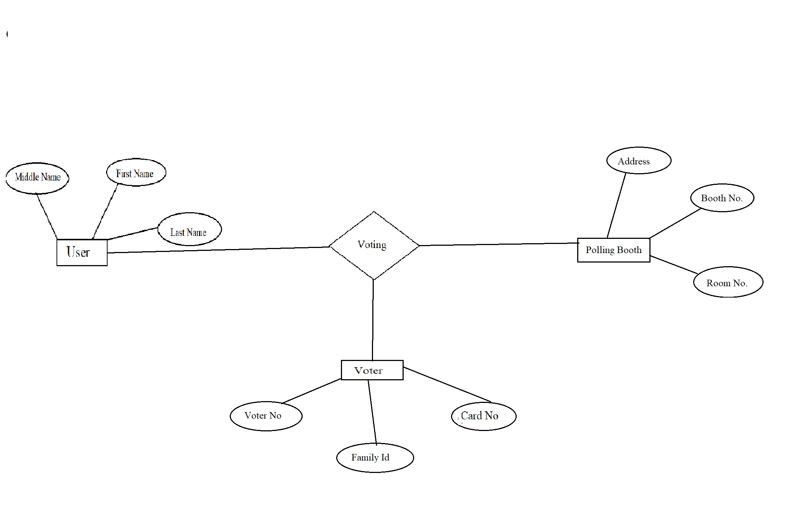

**Project Demonstration:**

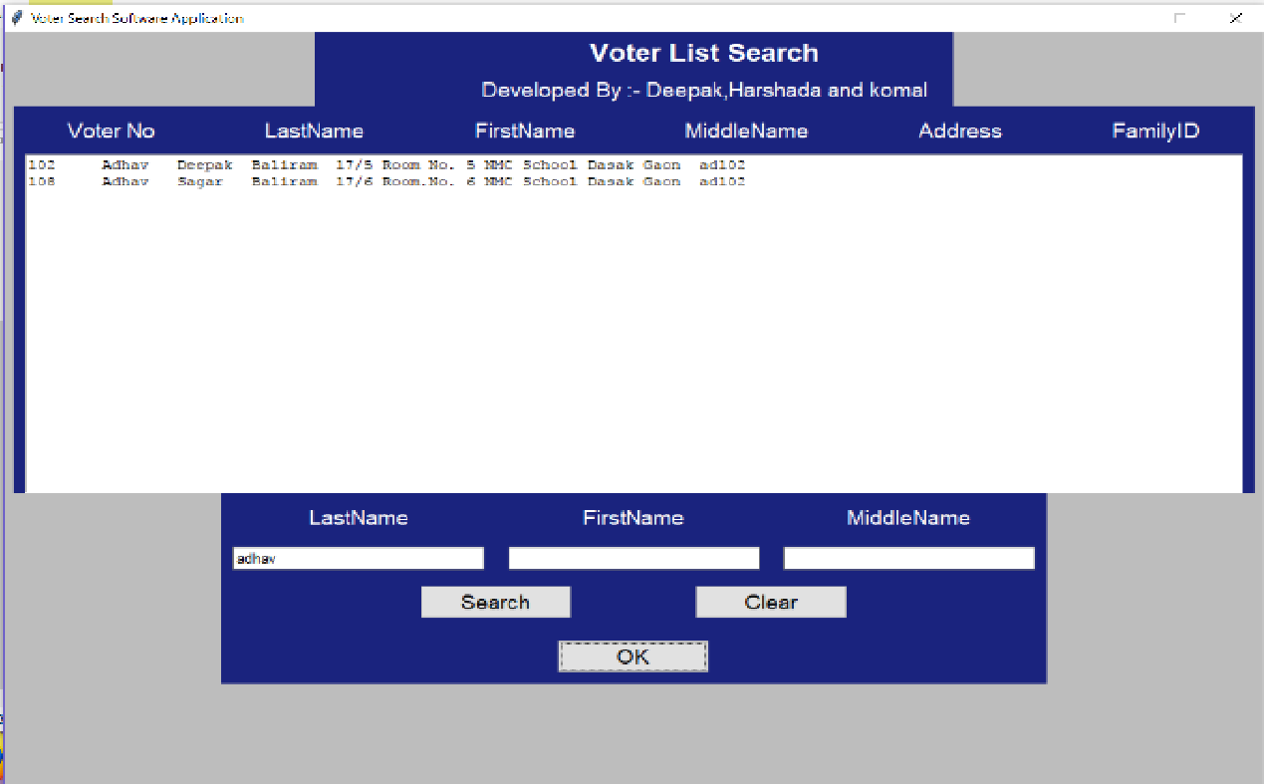

**Type your name in search boxes, and then click on search.**

**It display Voter No, LastName, FirstName, MiddleName, Address, FamilyID. Then click on OK button. Will display following window:**

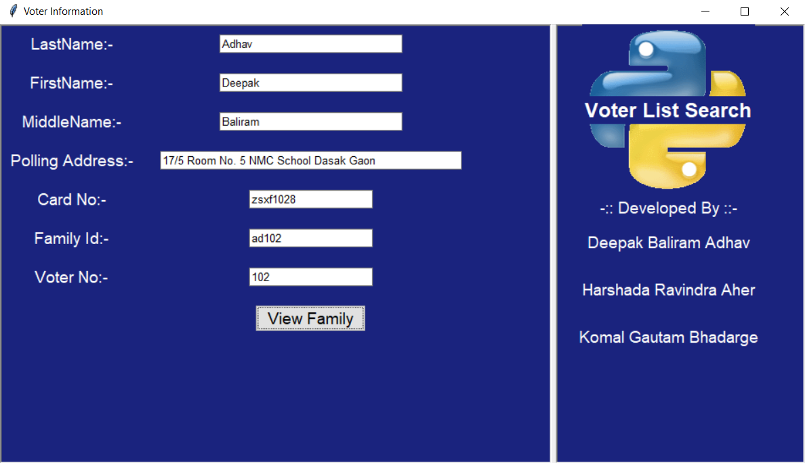

**After clicking on ViewFamily will display family members.**

